Cloud Concierge Performance Tips
Note: RAM helps overall system performance, but after about 8GB of RAM, RAM’s performance-helping ability quickly levels off. RAM’s true value is for applications that need to store data in memory rather than read/write it to a drive which is 10x to 100x slower than RAM.
Adding CPU power can help so long as the performance boost that is needed is CPU power…if the drive is slow or if all the RAM is used, more CPUs will not improve the performance because the CPU is not the bottleneck.
If your demo can be accessed via a browser, you will receive much better performance pointing your laptop’s browser at the demo instead of RDP’ing into the Instance and using the browser within the RDP session. There are 2 reasons for this improvement:
- The RDP session, in general, is somewhat slow such as using a mouse. RDP is really used to get into a system to make some quick changes…not to perform a 30-minute demo.
- The browser inside the VM/Instance is now fighting for system resources (RAM, CPU, hard drive read/writes) which means the Instance overall will perform a bit slower…using your laptop’s browser relieves the VM/Instance of the browser requirements and even video rendering.

Steps to Improve Performance:
Step 1: Open Task Manager and sort the Processes tab by CPU and see what applications are using the most CPU power.
Step 2: Open Task Manager and sort the Processes tab by Memory and see what applications are using the most RAM.
Step 3: Disable Services and Products you are not using. For example, the BA Enterprise 1.3.3 system turns on TM1, Cognos BI, DB2, and SQL Server by default. If you are not using TM1, disable it via Windows Services. The below 3 screenshots show the BA Enterprise 1.3.3 system’s RAM and CPU resources after a fresh boot, disabling TM1 Admin, and then also disabling TM1 Application. We can reduce RAM consumption by 10% (freeing up about 1GB memory) as well as reduce the number of Processes by 40%.
  - Fresh boot: 137 processes running and 47% RAM consumed
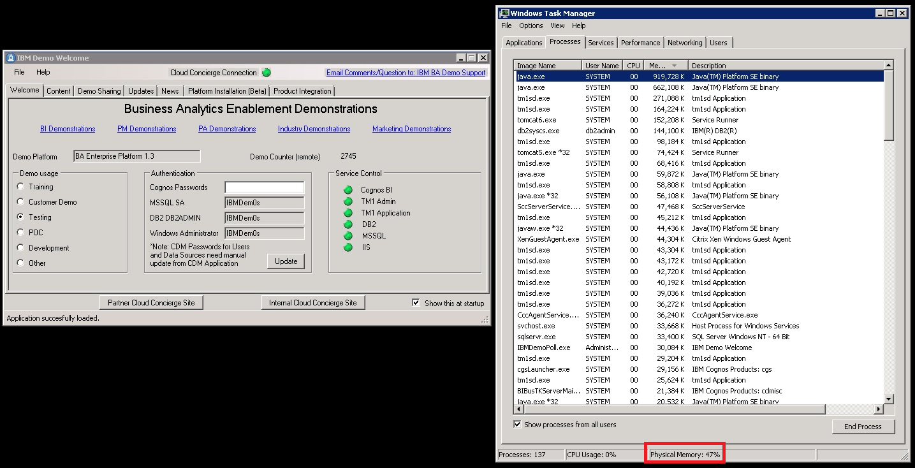
  - TM1 Admin disabled: 82 processes running and 38% RAM consumed
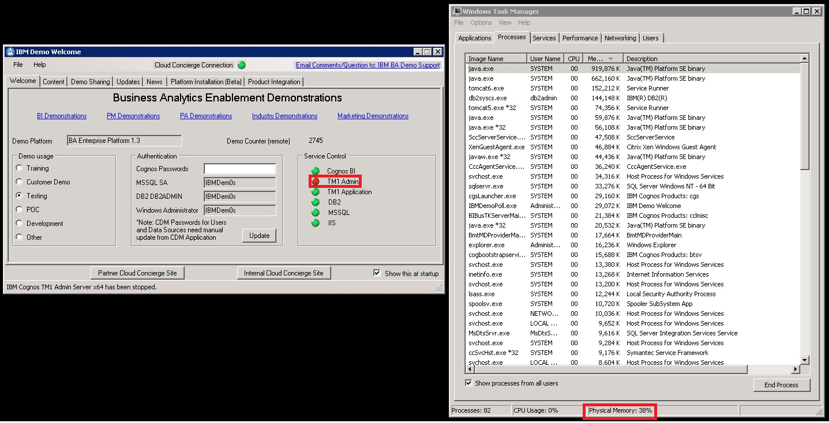

  - TM1 Application disabled: 80 processes running and 36% RAM consumed
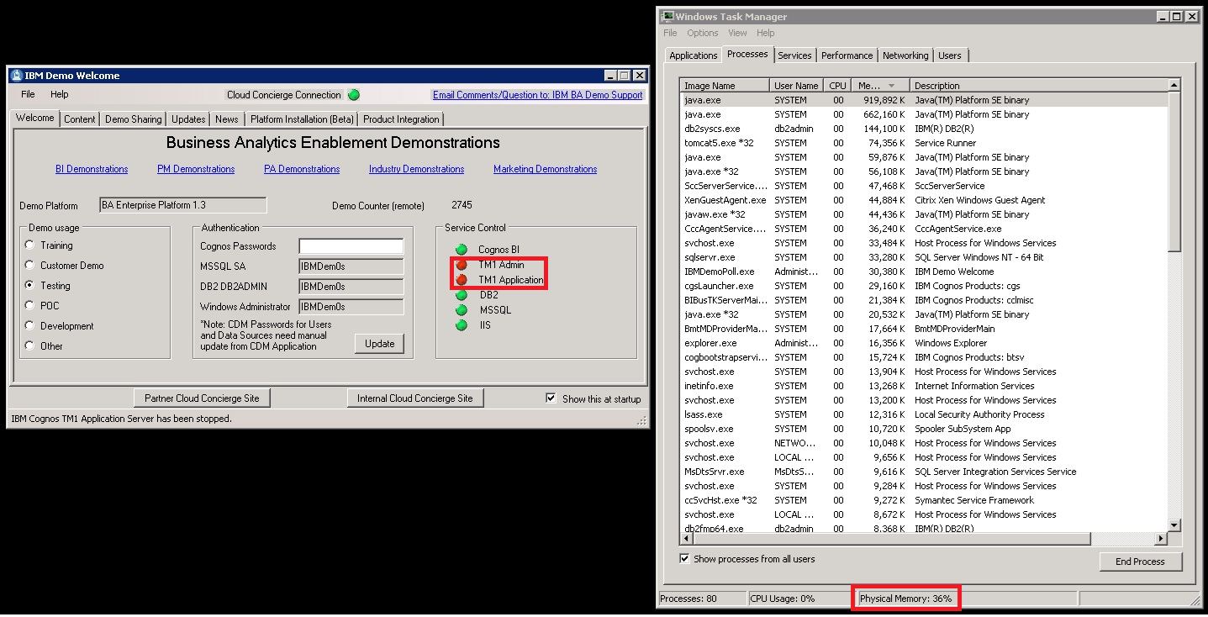
Step 4: If your demo is reachable by a web browser, use your laptop’s browser instead of RDP’ing into the system and using the browser inside the RDP session.
Step 5: If you still need more system resources, Cloud Concierge Support can increase the RAM as well as increase the # of CPU cores. Business justification will be needed.
Note: Please send an attached screen shot of the Task Manager’s Performance Tab as well as the duration which the upgrade is required so we can return it back to the default configuration when the upgrades are no longer necessary.
Step 6: Additionally, you could provision more than 1 copy of a System to create a tiered architecture. For example, you could provision 2 copies of the Enterprise 1.3.3 System. On the first Instance, disable DB2 and SQL Server. On the 2nd Instance, enable only DB2 and SQL Server and disable all the other BA products. Then, on the first instance, update the Data Sources to point to the 2nd Instance. This design is more real-world in that different products are on their own boxes…which will lead to best performance.

